Global GAME JAM

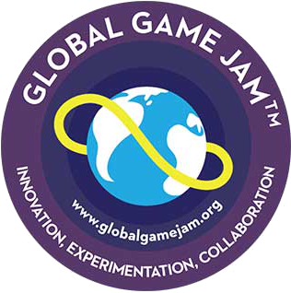



Details & Registration

goo.gl/JwJEOD

Teams

* Comprise 3-6 students
* Use any tools/software
* Bring any equipment
* Must register by Jan 24
* You may wait to team up

When/Where/How

* Begins Jan 24, 5:00pm
* Ends Jan 26, 5:00pm
* At Woodward 130
* Open all hours
* Registration is *Free*

Create a Game in 48 Hours!

Come join the annual Global Game Jam at UNCC. In a course of 48 hours, you and your team will design and develop a new video game or board game based on an announced theme. If you are a programmer, artist, or musician of any skill level, then game jams are great opportunities for you to enhance your skills and to meet awesome people.